zomato APP DEPLOYMENT: TERRAFORM AND JENKINS CI/CD

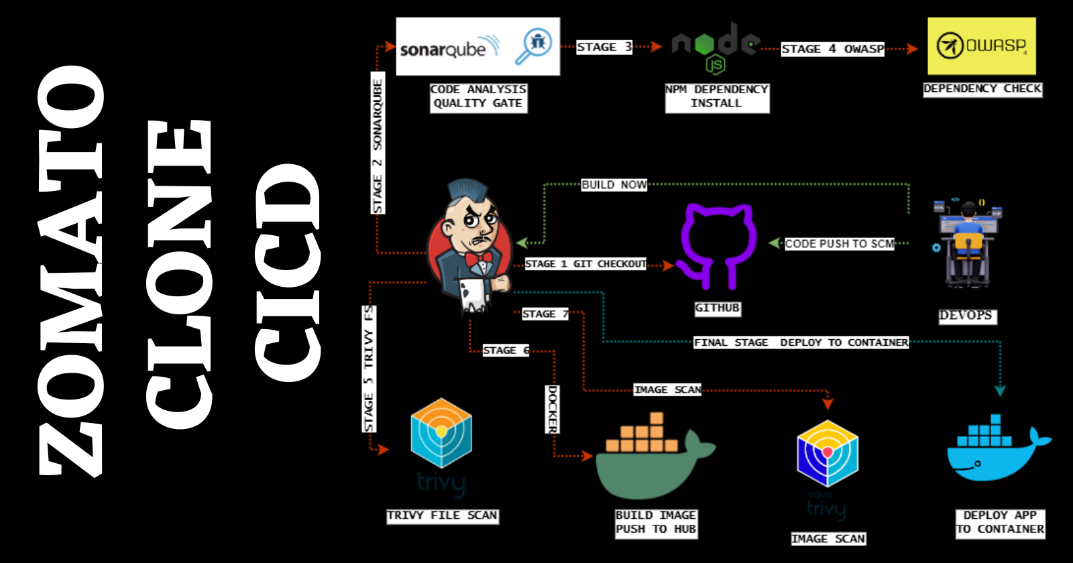

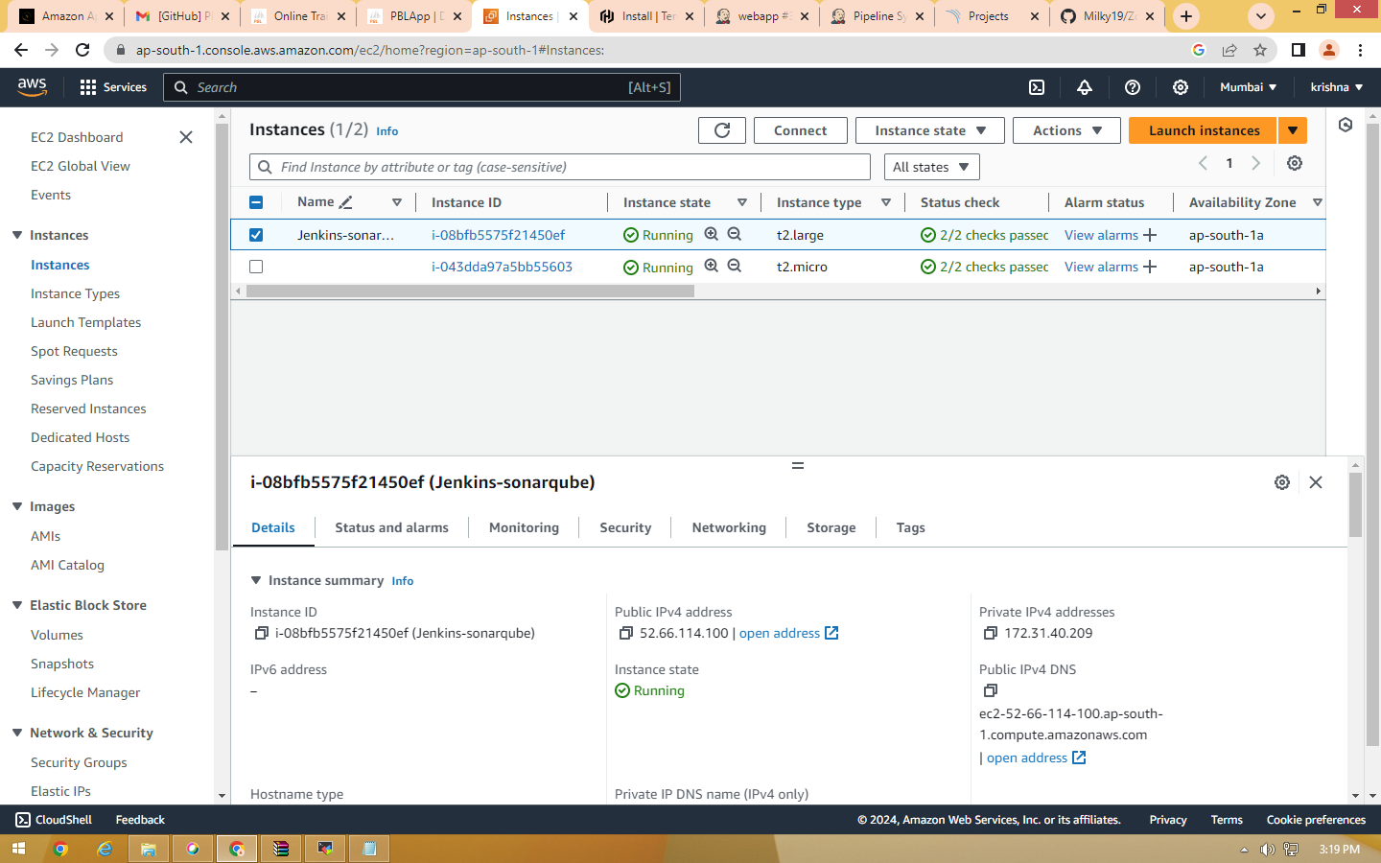

Step1: create an IAM user (we need to generate access and secret_key for programmatic access)
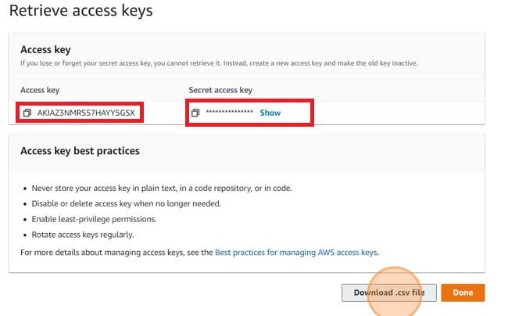

Step2: Aws Configure
aws configure
Provide your Aws Access key and Secret Access key
Step3: Install terraform

Step4: Terraform files and Provision Jenkins,sonar
Create main.tf
resource "aws_instance" "web" {
ami = "ami-0f5ee92e2d63afc18" #change ami id for different region
instance_type = "t2.large"
key_name = "MUMBAI-TERRA"
vpc_security_group_ids = [aws_security_group.Jenkins-sg.id]
user_data = templatefile("./install.sh", {})
tags = {
Name = "Jenkins-sonarqube"
}
root_block_device {
volume_size = 30
}
}
resource "aws_security_group" "Jenkins-sg" {
name = "Jenkins-sg"
description = "Allow TLS inbound traffic"
ingress = [
for port in [22, 80, 443, 8080, 9000, 3000] : {
description = "inbound rules"
from_port = port
to_port = port
protocol = "tcp"
cidr_blocks = ["0.0.0.0/0"]
ipv6_cidr_blocks = []
prefix_list_ids = []
security_groups = []
self = false
}
]
egress {
from_port = 0
to_port = 0
protocol = "-1"
cidr_blocks = ["0.0.0.0/0"]
}
tags = {
Name = "jenkins-sg"
}
}

Create user-data file like install.sh
#!/bin/bash
sudo apt update -y
wget -O - https://packages.adoptium.net/artifactory/api/gpg/key/public | tee /etc/apt/keyrings/adoptium.asc
echo "deb [signed-by=/etc/apt/keyrings/adoptium.asc] https://packages.adoptium.net/artifactory/deb $(awk -F= '/^VERSION_CODENAME/{print$2}' /etc/os-release) main" | tee /etc/apt/sources.list.d/adoptium.list
sudo apt update -y
sudo apt install temurin-17-jdk -y
/usr/bin/java --version
curl -fsSL https://pkg.jenkins.io/debian-stable/jenkins.io-2023.key | sudo tee /usr/share/keyrings/jenkins-keyring.asc > /dev/null
echo deb [signed-by=/usr/share/keyrings/jenkins-keyring.asc] https://pkg.jenkins.io/debian-stable binary/ | sudo tee /etc/apt/sources.list.d/jenkins.list > /dev/null
sudo apt-get update -y
sudo apt-get install jenkins -y
sudo systemctl start jenkins
sudo systemctl status jenkins
#install docker
sudo apt-get update
sudo apt-get install docker.io -y
sudo usermod -aG docker ubuntu
newgrp docker
sudo chmod 777 /var/run/docker.sock
docker run -d --name sonar -p 9000:9000 sonarqube:lts-community
#install trivy
sudo apt-get install wget apt-transport-https gnupg lsb-release -y
wget -qO - https://aquasecurity.github.io/trivy-repo/deb/public.key | gpg --dearmor | sudo tee /usr/share/keyrings/trivy.gpg > /dev/null
echo "deb [signed-by=/usr/share/keyrings/trivy.gpg] https://aquasecurity.github.io/trivy-repo/deb $(lsb_release -sc) main" | sudo tee -a /etc/apt/sources.list.d/trivy.list
sudo apt-get update
sudo apt-get install trivy -y

NOW EXECUTE THE TERRAFORM SCRIPT
terraform init
terraform validate
terraform plan
terraform apply

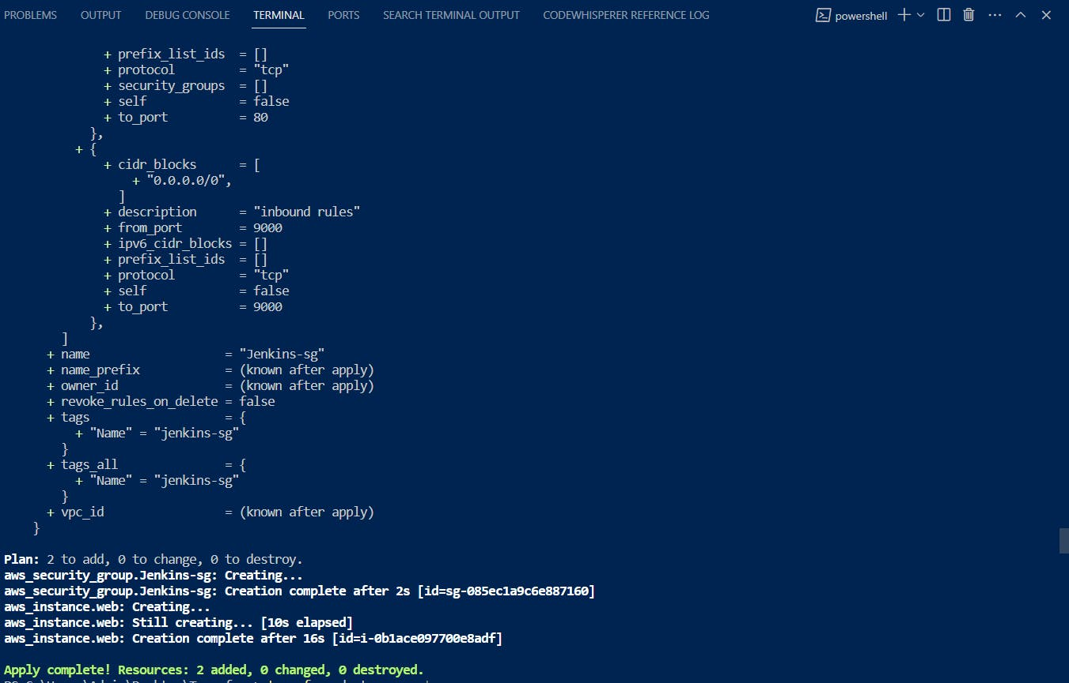
<instance-ip:8080> #jenkins
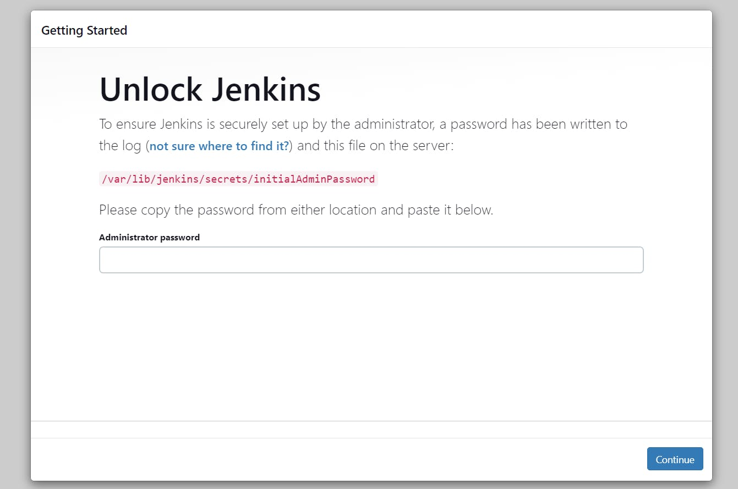
sudo cat /var/lib/jenkins/secrets/initialAdminPassword

Unlock Jenkins using an administrative password and install the suggested plugins.
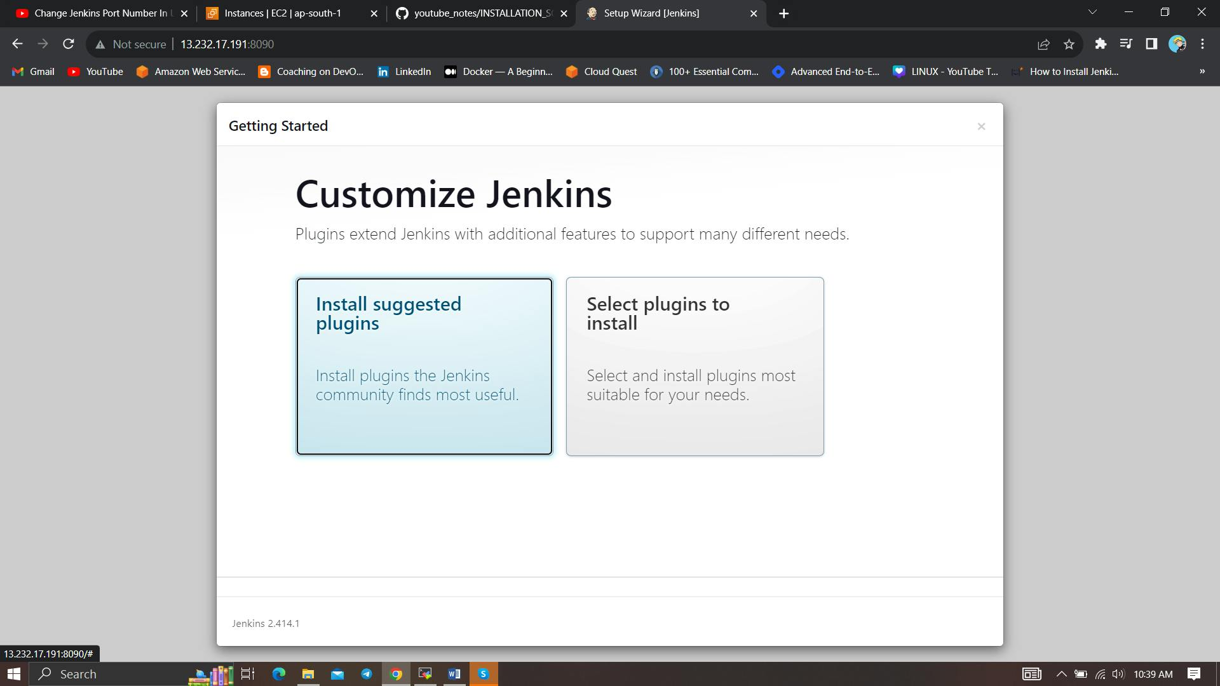
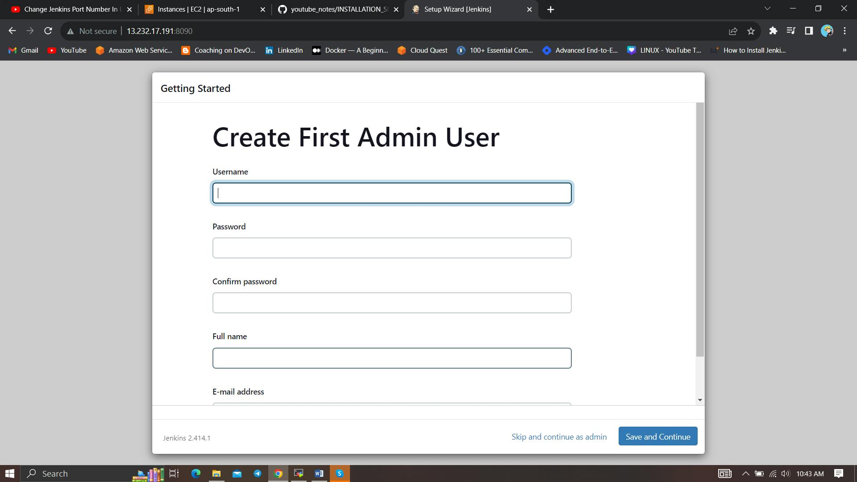

Create a user click on save and continue.
Jenkins Getting Started Screen.
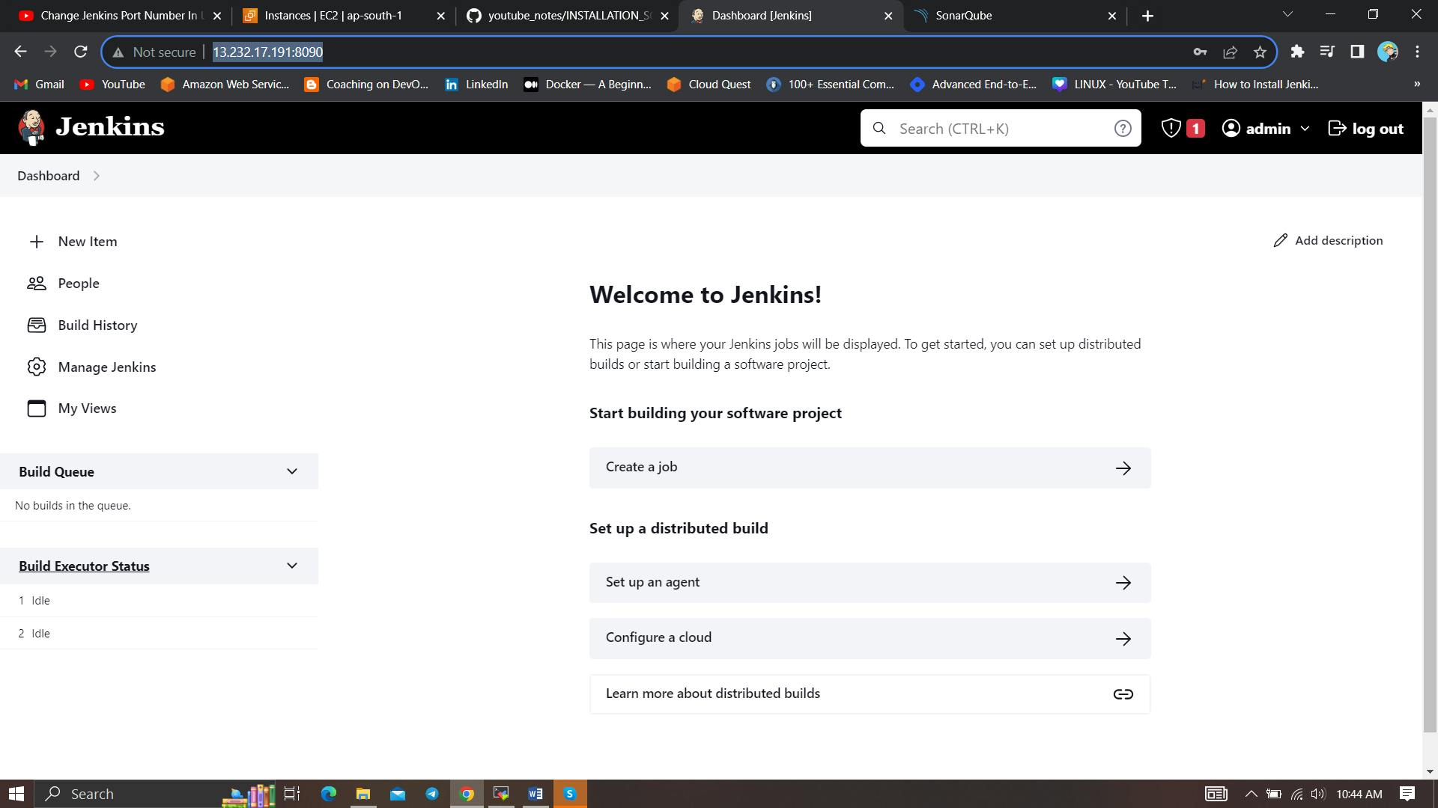
Copy your Public key again and paste it into a new tab
<instance-public-ip:9000>
Now our sonarqube is up and running
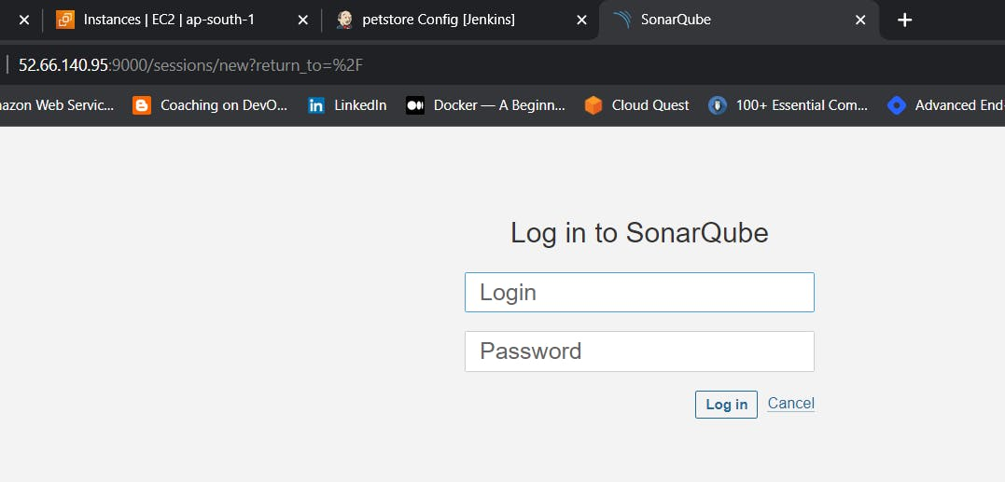
Enter username and password, click on login and change password
username admin
password admin
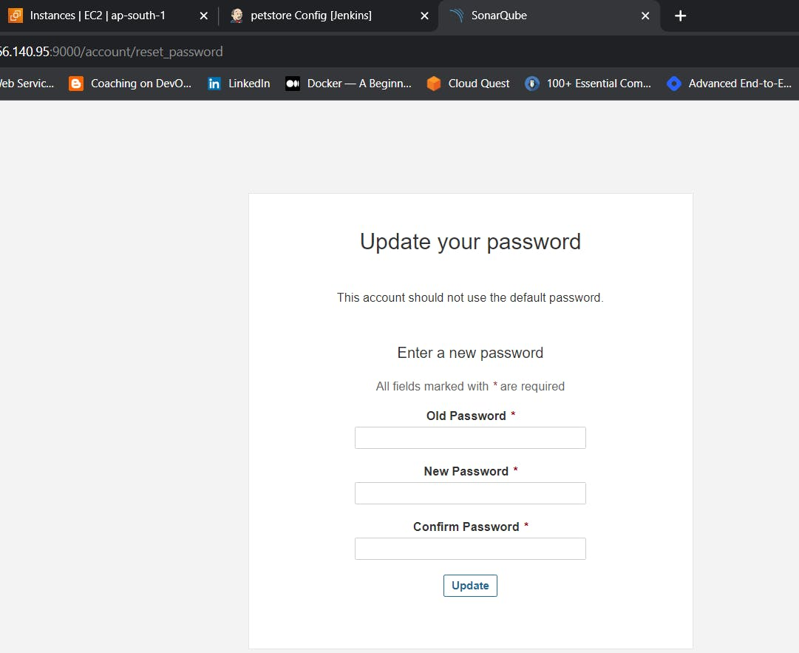

Update New password, This is Sonar Dashboard.
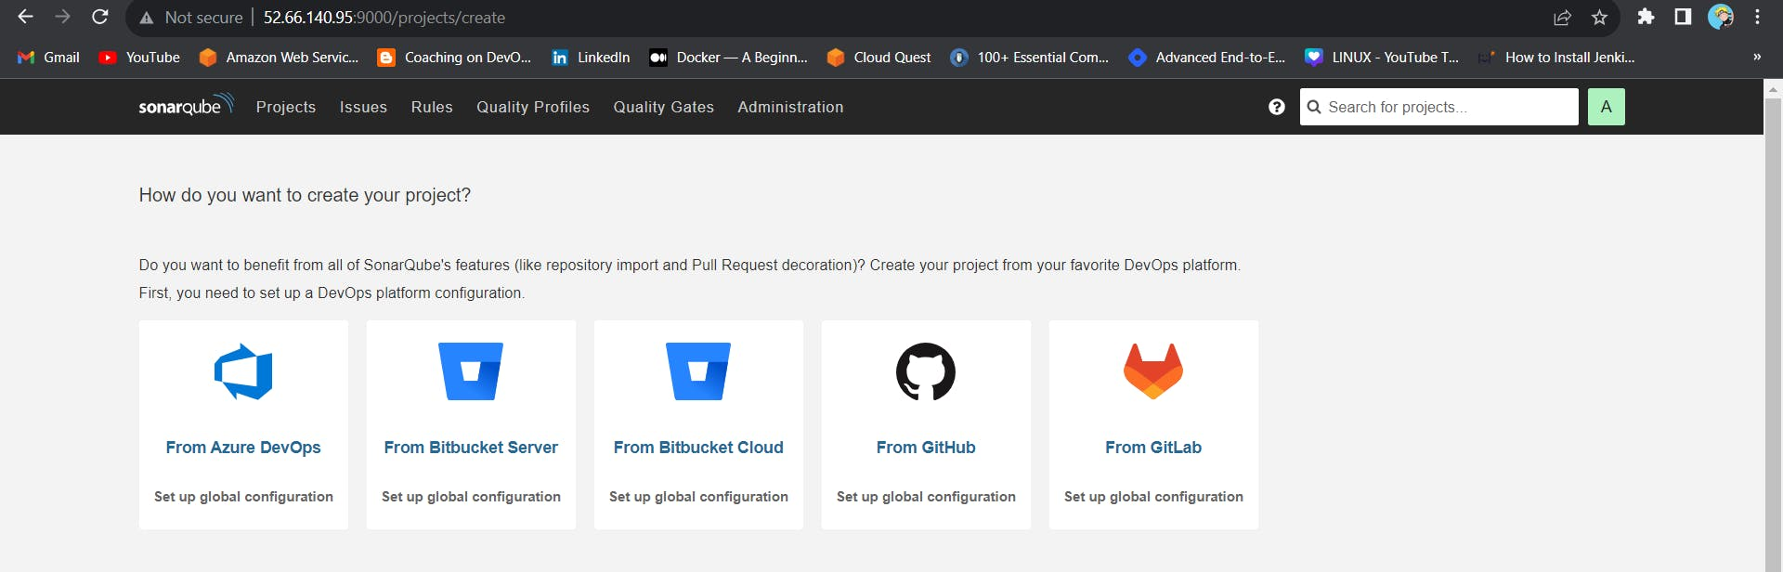

Step 5 — Install Plugins like JDK, Sonarqube Scanner, NodeJs, OWASP Dependency Check

5A — Install Plugin
Goto Manage Jenkins →Plugins → Available Plugins →
Install below plugins
1 → Eclipse Temurin Installer (Install without restart)
2 → SonarQube Scanner (Install without restart)
3 → NodeJs Plugin (Install Without restart)
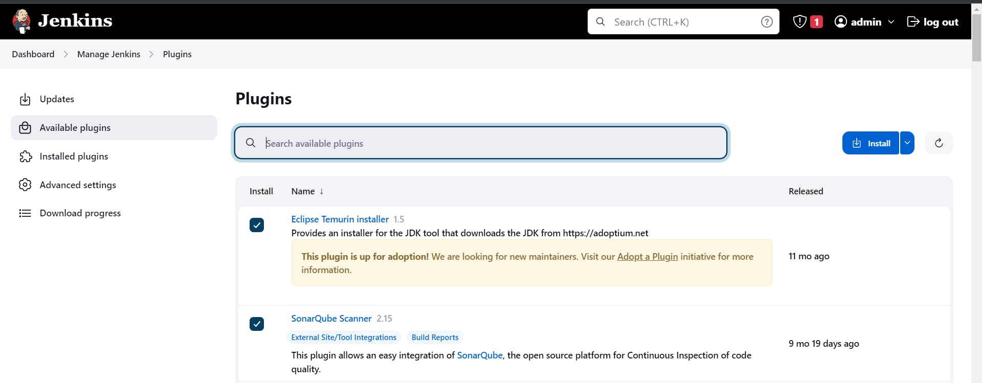
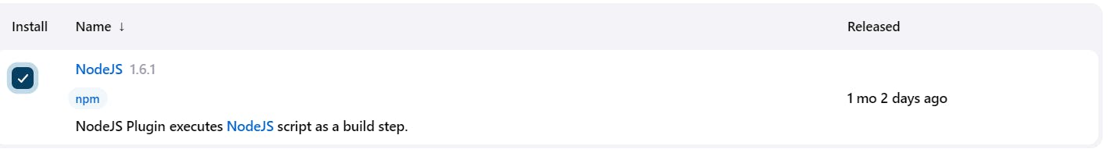

5B — Configure Java and Nodejs in Global Tool Configuration
Goto Manage Jenkins → Tools → Install JDK(17) and NodeJs(16)→ Click on Apply and Save
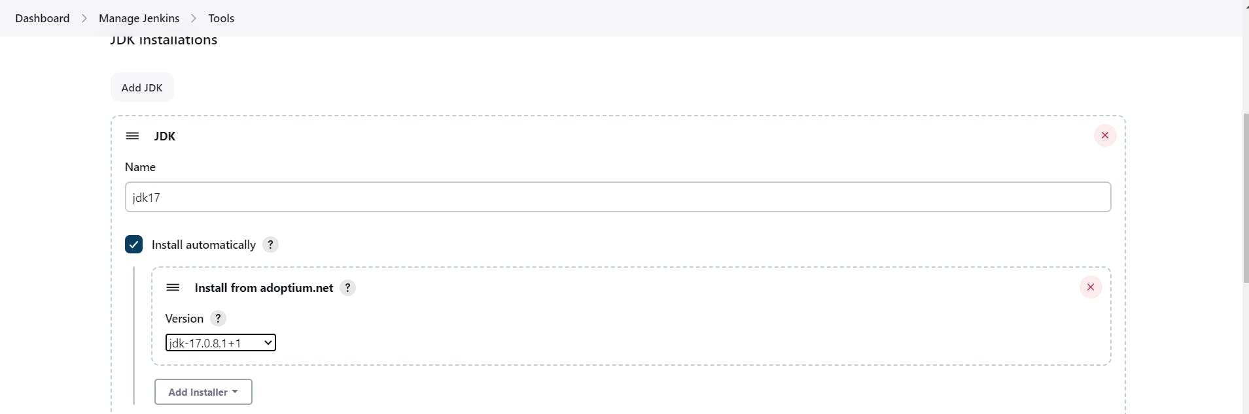
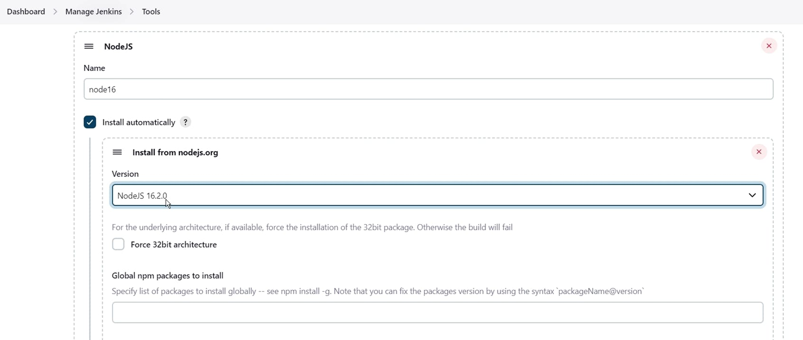

Step 6 — Configure Sonar Server in Manage Jenkins
Grab the Public IP Address of your EC2 Instance, Sonarqube works on Port 9000, so <Public IP>:9000. Goto your Sonarqube Server. Click on Administration → Security → Users → Click on Tokens and Update Token → Give it a name → and click on Generate Token

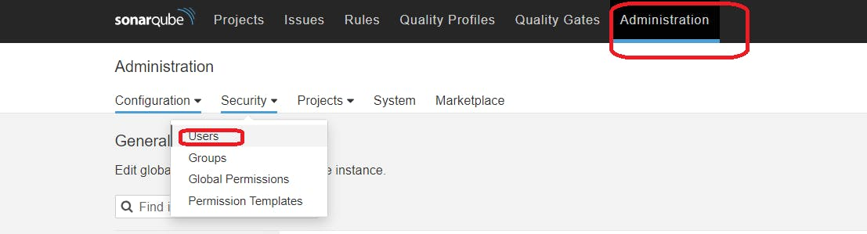
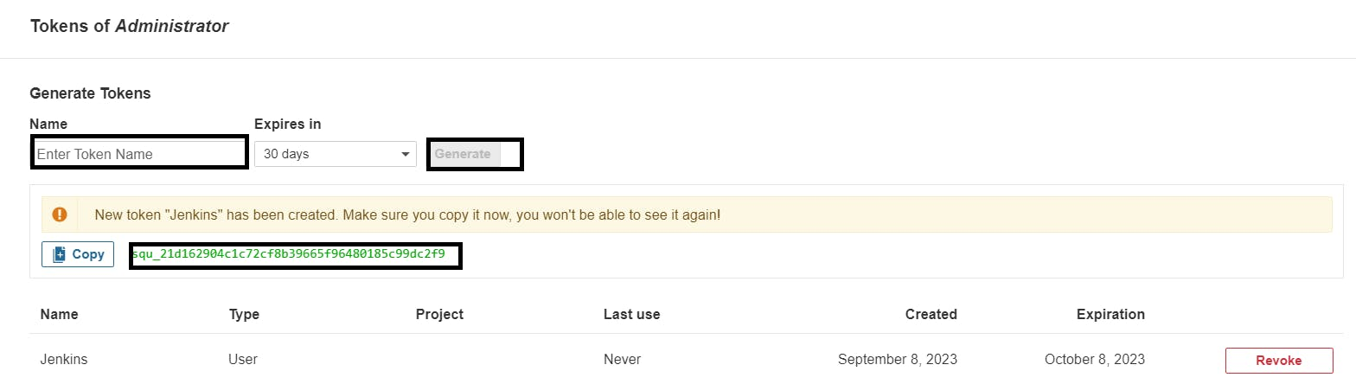
copy Token
Goto Jenkins Dashboard → Manage Jenkins → Credentials → Add Secret Text. It should look like this
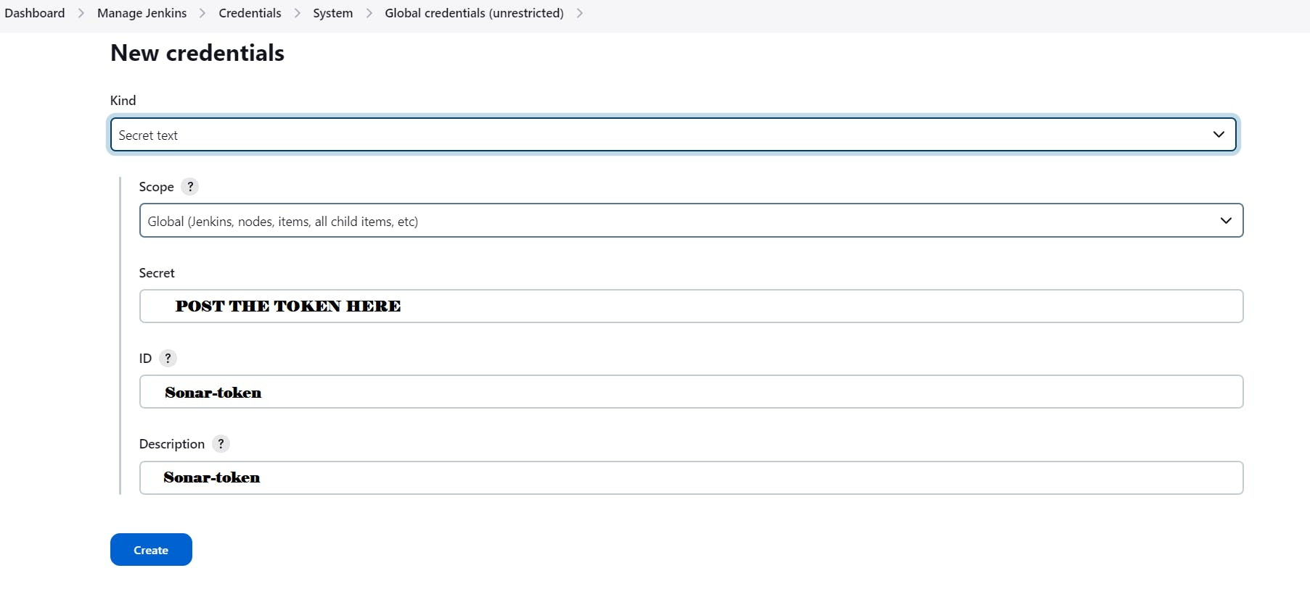
You will this page once you click on create
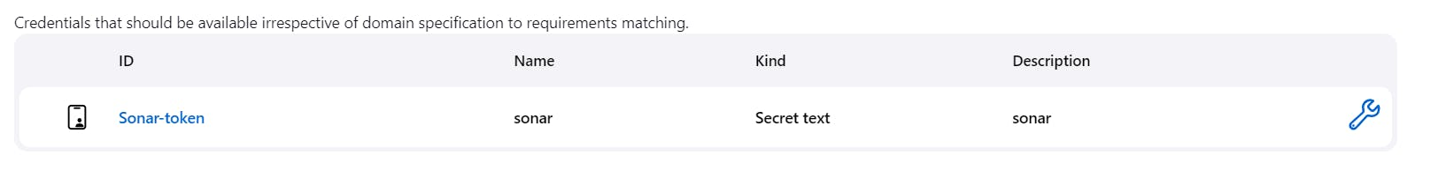
Now, go to Dashboard → Manage Jenkins → System and Add like the below image.
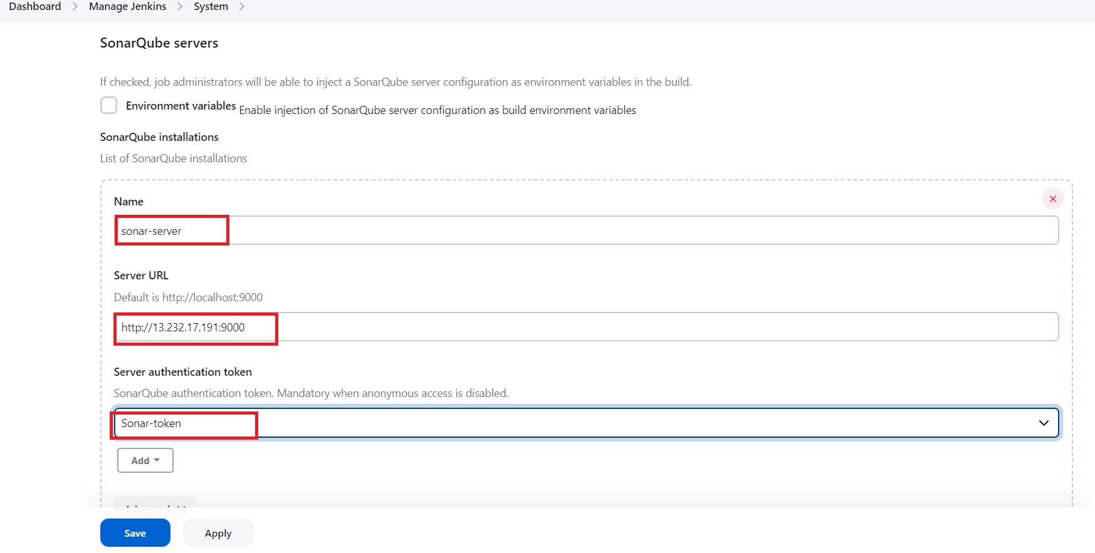
Click on Apply and Save
The Configure System option is used in Jenkins to configure different server
Global Tool Configuration is used to configure different tools that we install using Plugins
We will install a sonar scanner in the tools.
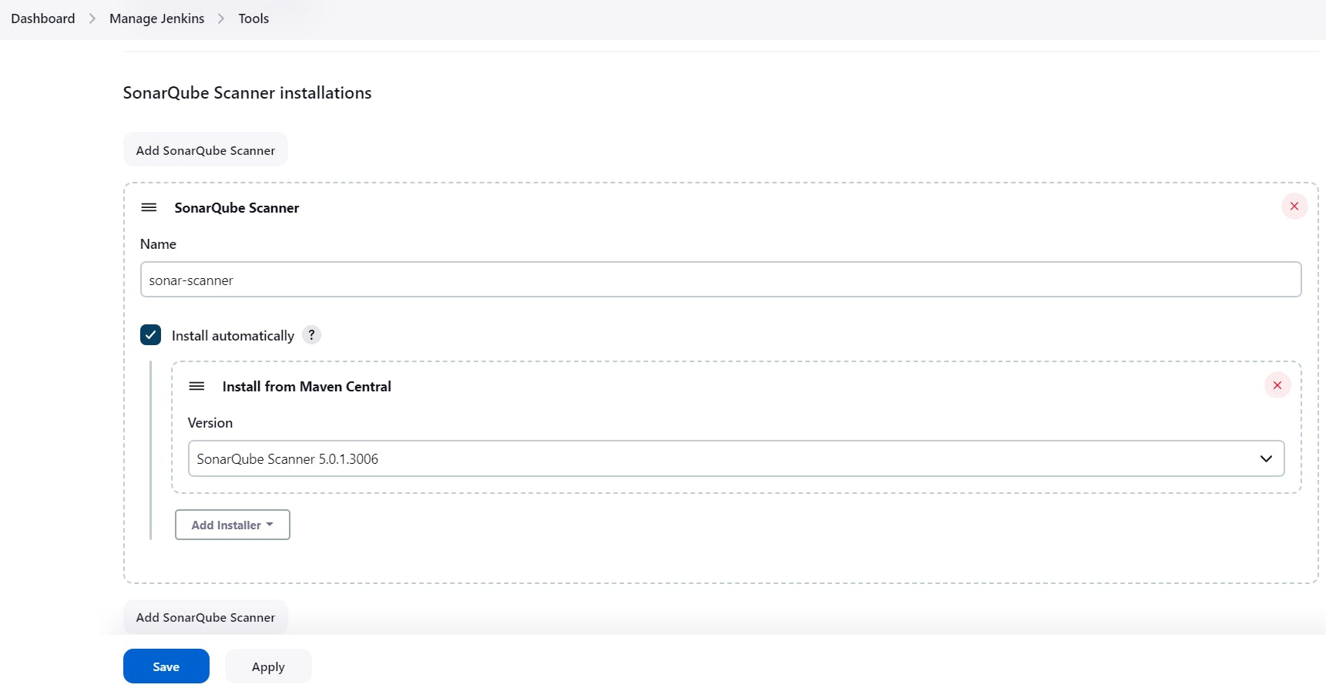
In the Sonarqube Dashboard add a quality gate also
Administration–> Configuration–>Webhooks
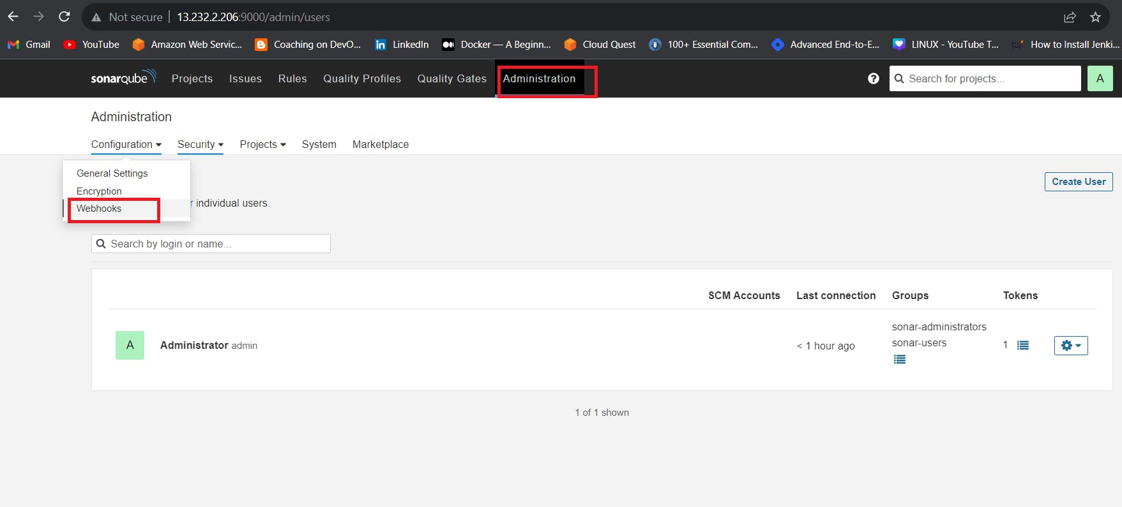
Click on Create
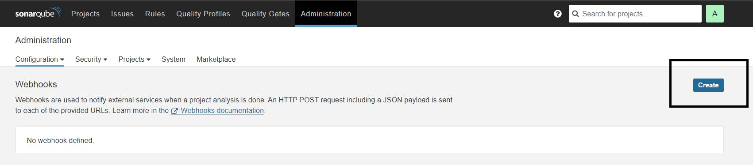
Add details
#in url section of quality gate
<http://jenkins-public-ip:8080>/sonarqube-webhook/
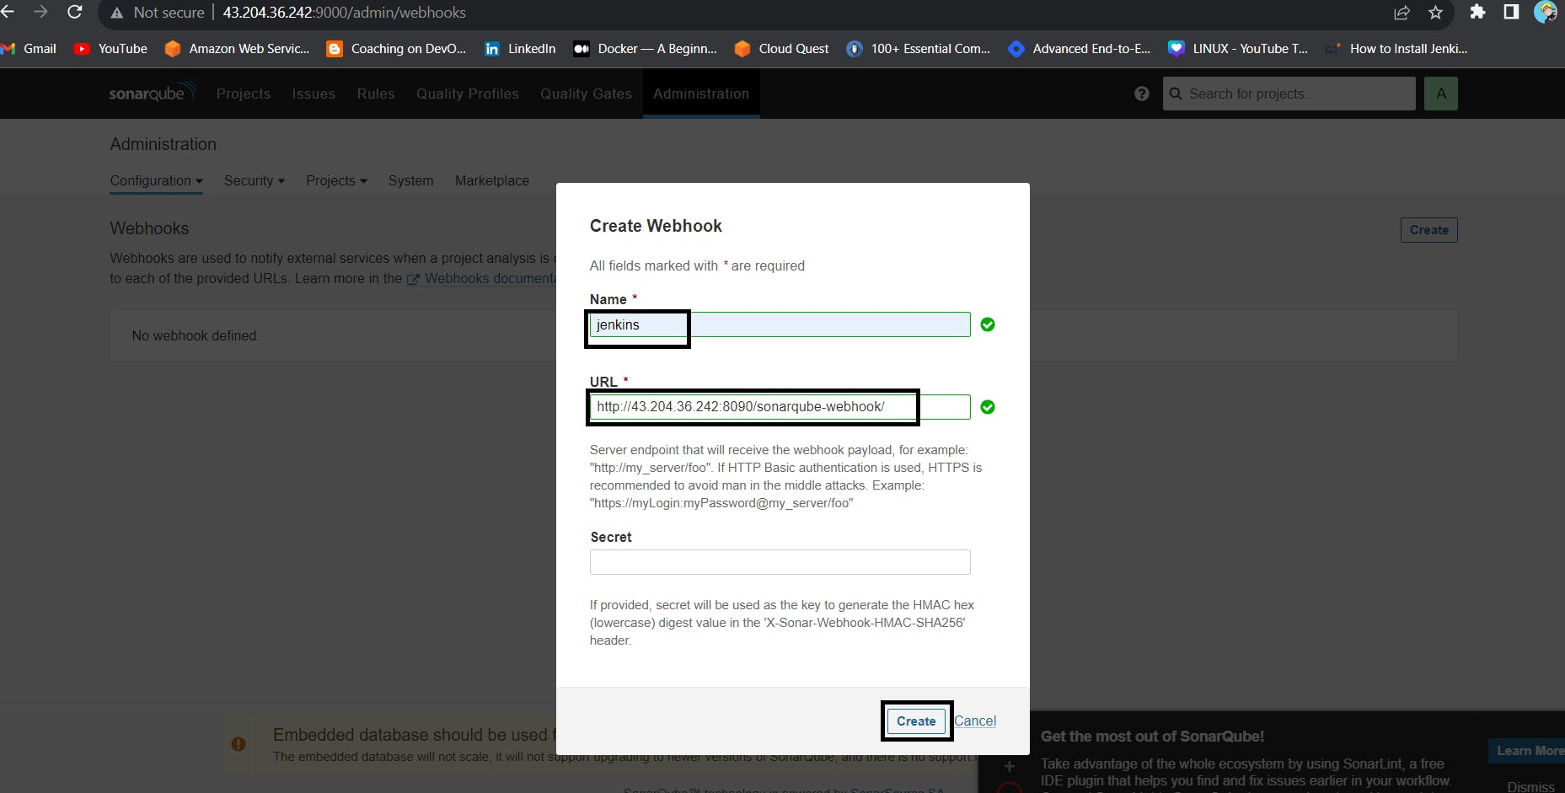
GOTO Jenkins dashboard create Jenkins pipeline job
pipeline{
agent any
tools{
jdk 'jdk17'
nodejs 'node16'
}
environment {
SCANNER_HOME=tool 'sonar-scanner'
}
stages {
stage('clean workspace'){
steps{
cleanWs()
}
}
stage('Checkout from Git'){
steps{
git branch: 'main', url: 'https://github.com/Milky19/Zomato-Clone.git'
}
}
stage("Sonarqube Analysis "){
steps{
withSonarQubeEnv('sonar-server') {
sh ''' $SCANNER_HOME/bin/sonar-scanner -Dsonar.projectName=Amazon \
-Dsonar.projectKey=Amazon '''
}
}
}
stage("quality gate"){
steps {
script {
waitForQualityGate abortPipeline: false, credentialsId: 'Sonar-token'
}
}
}
stage('Install Dependencies') {
steps {
sh "npm install"
}
}
}
}
Click on Build now, you will see the stage view like this
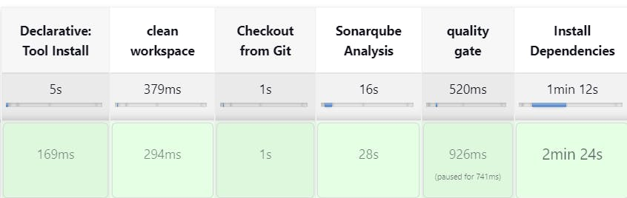
To see the report, you can go to Sonarqube Server and go to Projects.
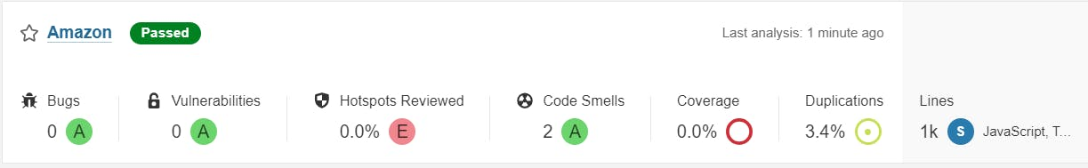
You can see the report has been generated and the status shows as passed. You can see that there are 1k lines it scanned. To see a detailed report, you can go to issues.

Step 7 — Install OWASP Dependency Check Plugins
GotoDashboard → Manage Jenkins → Plugins → OWASP Dependency-Check. Click on it and install it without restart.
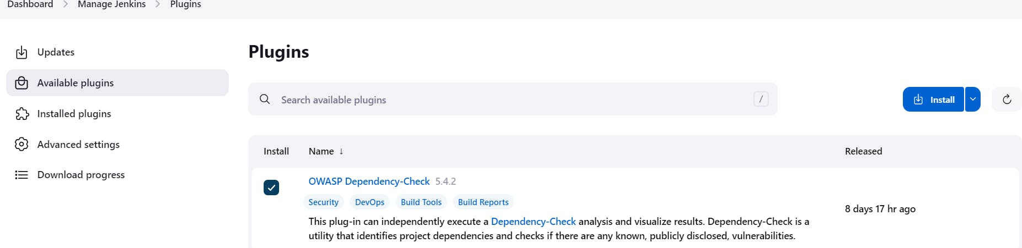
First, we configured the Plugin and next, we had to configure the Tool
Goto Dashboard → Manage Jenkins → Tools →
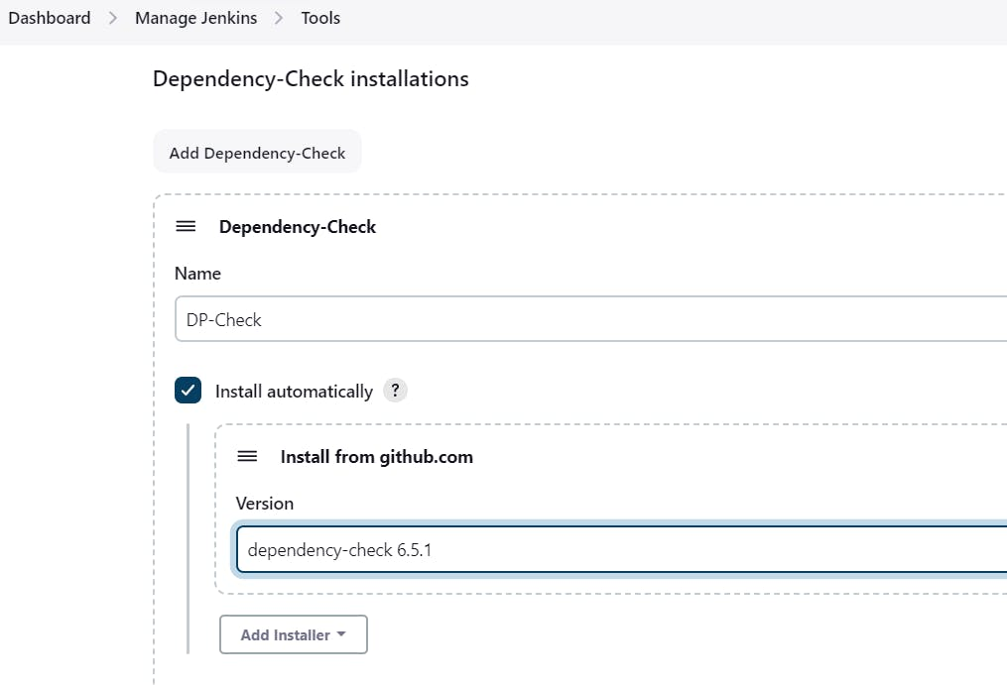
Click on Apply and Save here.
Now go configure → Pipeline and add this stage to your pipeline and build.
stage('OWASP FS SCAN') {
steps {
dependencyCheck additionalArguments: '--scan ./ --disableYarnAudit --disableNodeAudit', odcInstallation: 'DP-Check'
dependencyCheckPublisher pattern: '**/dependency-check-report.xml'
}
}
stage('TRIVY FS SCAN') {
steps {
sh "trivy fs . > trivyfs.txt"
}
}
The stage view would look like this,
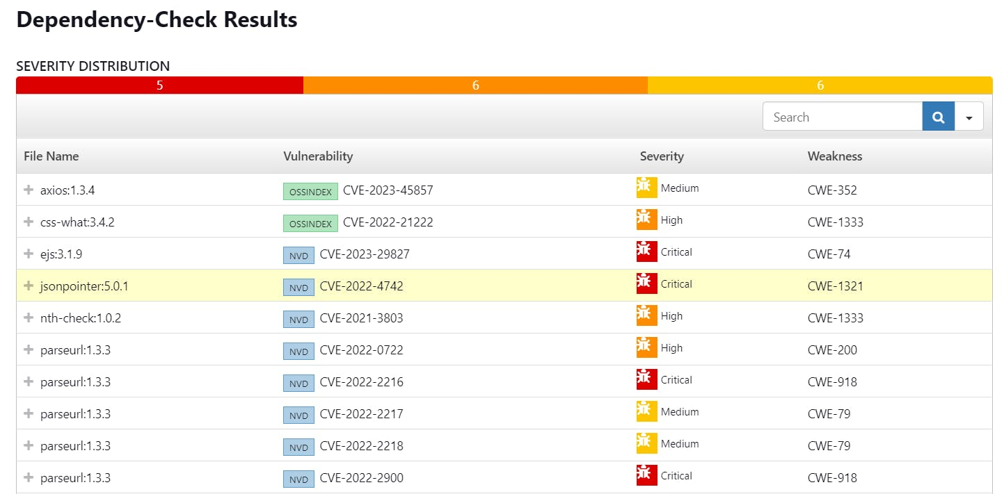

Step 8 — Docker Image Build and Push
We need to install the Docker tool in our system, Goto Dashboard → Manage Plugins → Available plugins → Search for Docker and install these plugins
Docker
Docker Commons
Docker Pipeline
Docker API
docker-build-step
and click on install without restart
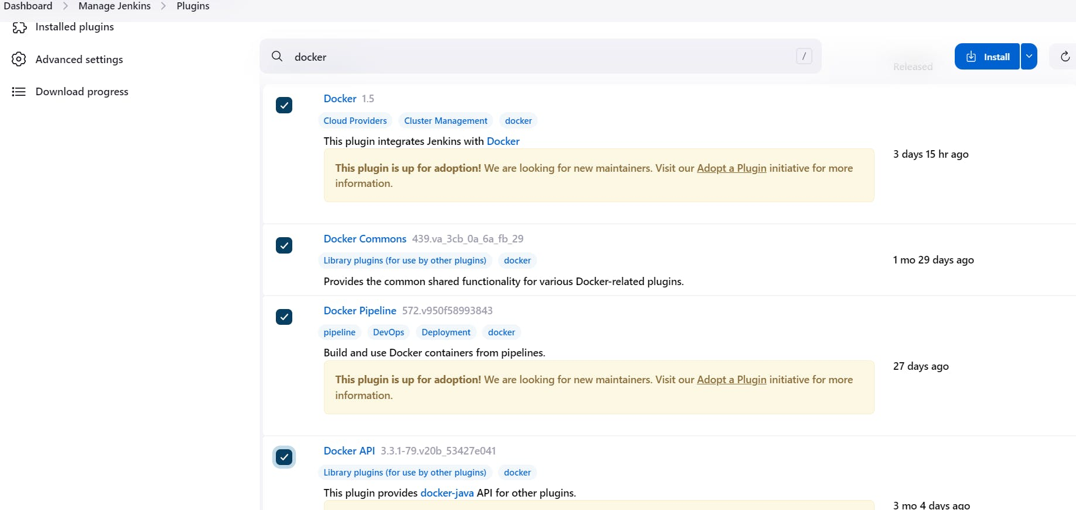
Now, goto Dashboard → Manage Jenkins → Tools →
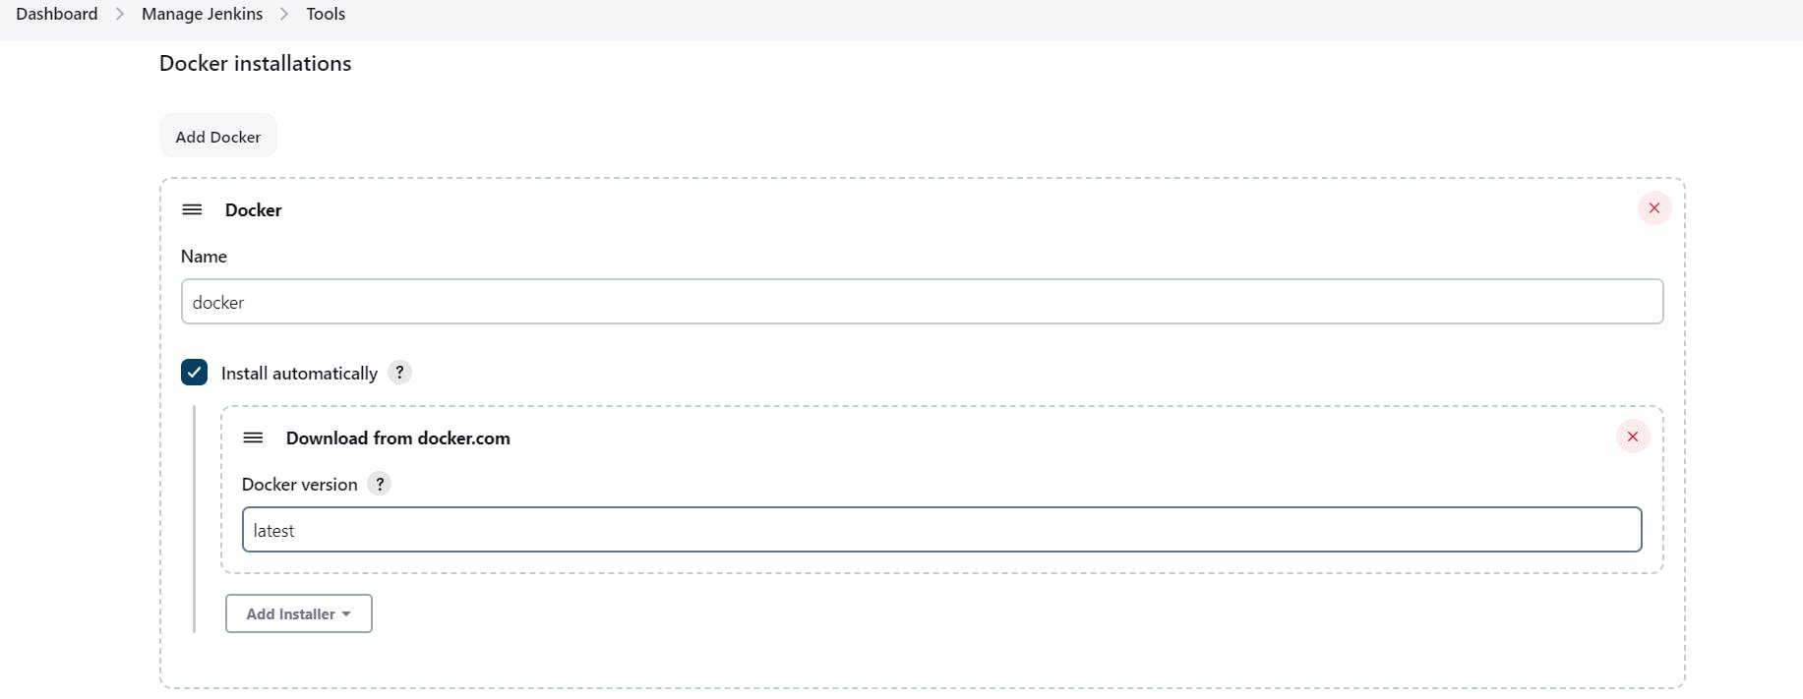
Add DockerHub Username and Password under Global Credentials
stage("Docker Build & Push"){
steps{
script{
withDockerRegistry(credentialsId: 'docker', toolName: 'docker'){
sh "docker build -t zomato ."
sh "docker tag zomato hanvitha/zomato:latest "
sh "docker push hanvitha/zomato:latest "
}
}
}
}
stage('Deploy to container'){
steps{
sh 'docker run -d --name zomato -p 3000:3000 hanvitha/zomato:latest'
}
}
}
}

You will see the output below, with a dependency trend.
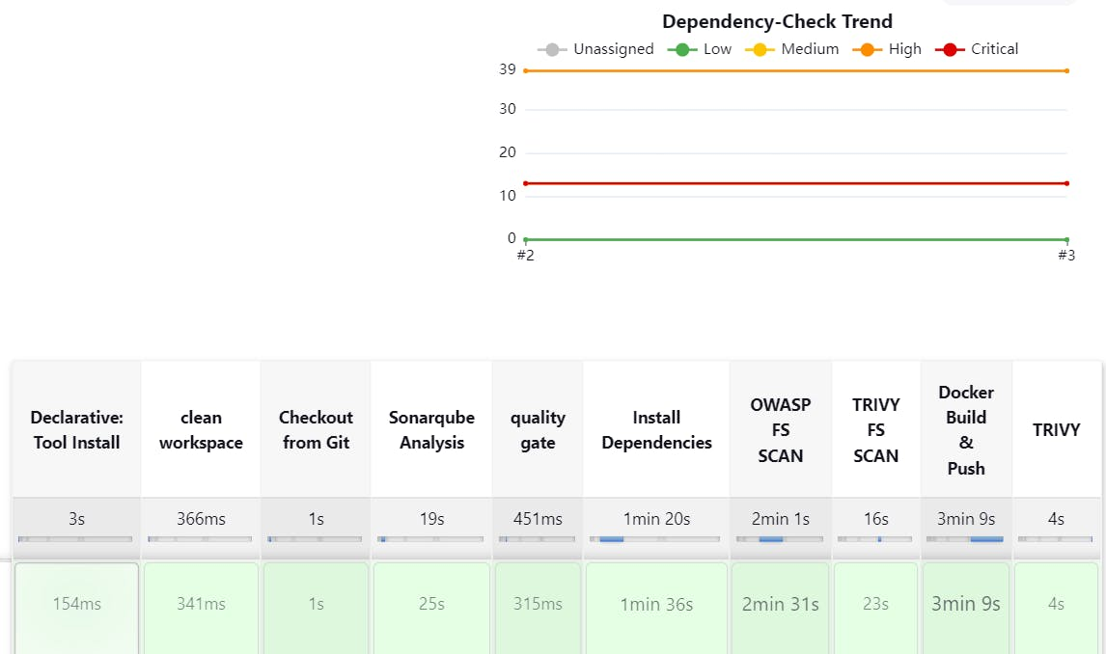
When you log in to Dockerhub, you will see a new image is created
Now Run the container to see if the game coming up or not by adding the below stage
stage('Deploy to container'){
steps{
sh 'docker run -d --name amazon -p 3000:3000 hanvitha/amazon:latest'
}
}
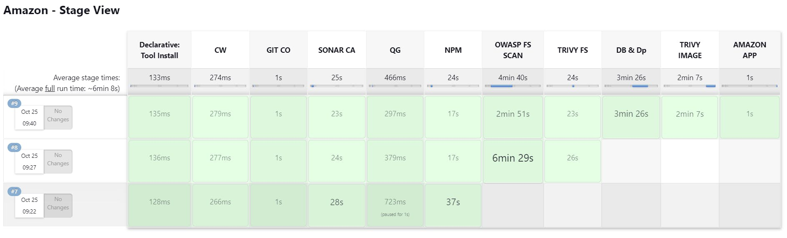
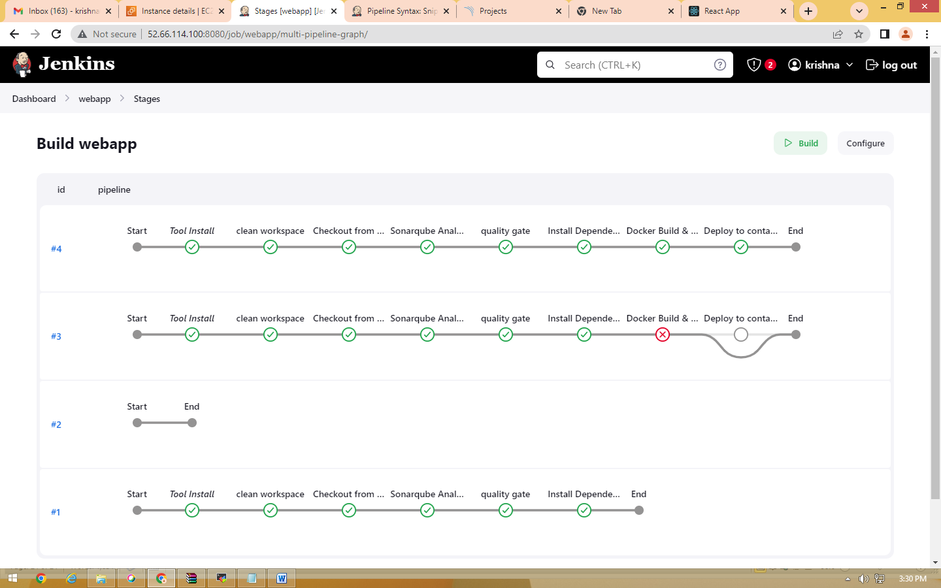

<Jenkins-public-ip:3000>
You will get this output


